## FACIAL EXPRESSION AND EMOTION RECOGNITION

## 

A Social Internship Report

Submitted in the partial fulfillment of the requirements for the award of the degree of

# Bachelor of Technology in

Department of Computer Science and Engineering

By

MANIDEEP REDDY (2010030309)

I KAUSTUBH SASTRY (2010030064)

K.V. MANOHAR KARTHIK (2010030197)

M.ABHIRAM (2010030457)

Under the supervision of

# Dr.K.Sreenivasa Rao (PROFESSOR )



Department of Computer Science and Engineering

K L University Hyderabad,

Aziz Nagar, Moinabad Road, Hyderabad – 500 075, Telangana, India.

March, 2022

**TABLE OF CONTENTS**

1. introduction
2. LITERATURE SURVEY
3. METHODOLOGY
4. CODE SCREENS
5. RESULT
6. CODE SCREENS
7. FUTURE ENHANCEMENTS
8. SOCIAL CONTRIBUTION
9. REFERENCES

**INTRODUCTION:**

* Recognizing facial expressions would help systems to detect if people were happy or sad as a human being can. This will allow software’s and AI systems to provide an even better experience to humans in various applications. From detecting probable suicides and stopping them to playing mood-based music there is a wide variety of applications where emotion detection or mood detection can play a vital role in AI applications.
* The system works on CNN (convolutional neural network) for extracting the physiological signals and make a prediction. The results can be drawn out by scanning the person’s image through a camera and then correlate it with a training dataset to predict one’s state of emotions.

**LITERATURE SURVEY:**

We have gone through many articles available to us through various mediums, we have found the article that provide us with the main information regarding the project and which are proved as very crucial for the project. The articles are as follows [1] TarunKumar,Dharmender Singh,Kushwaha’s book named as An Efficient Approach for Detection of facial landmarks ,the book provided with the basic knowledge of how to identify the faces in the frame we want to. From the technique stated in the book, we found out that, the technique They reduce the risk of false detections.[2] H. A.Rahim; U.U.Sheikh; A. S. M. Zain; W. N. F. W. Ariffin’s article named as Emotion detection using frame monitoring for smart surveillance system, the article mainly speaks of using emotion detection of security and surveillance purposes, we can use some of the techniques described for our project. The main con found from the articles technique is it is easy to implement and can be reliable enough to produce efficient results.[3] Josep Maria Salanova Grau, Luigi Selmi’s article named as Multisource Data Framework for Multi State emotion Estimation, the article mainly deals with the framework of the data ,if there are multisource data ,then it deals with merging the data from different sources to provide reliable to results to the user.[4] Donghyeon Yoon,jeongheon Song’s article named as Determination of Emotional state through Convolutional Neural Network, the articles mainly covers the topics of determining the emotional state using the concepts of deep learning ,mainly the topic called as conventional neural network (c.n.n), the main advantage of using this method is that,it is having a feature called as Random uncertainty. If a user encounters enough cameras, the certainty of the estimation increases tremendously .these are the articles we referred while we drafted our model.

**METHODOLOGY:** Convolutional neural network (CNN) is the most popular way of analyzing images. CNN is different from a multi-layer perceptron (MLP) as they have hidden layers, called convolutional layers. The proposed method is based on a two-level CNN framework. The first level recommended is background removal [29], used to extract emotions from an image, as shown in Fig. 1. Here, the conventional CNN network module is used to extract primary expressional vector (EV). The expressional vector (EV) is generated by tracking down relevant facial points of importance. EV is directly related to changes in expression. The EV is obtained using a basic perceptron unit applied on a background-removed face image. In the proposed FERC model, we also have a non-convolutional perceptron layer as the last stage. Each of the convolutional layers receives the input data (or image), transforms it, and then outputs it to the next level. This transformation is convolution operation, as shown in Fig. 2. All the convolutional layers used are capable of pattern detection. Within each convolutional layer, four filters were used. The input image fed to the first-part CNN (used for background removal) generally consists of shapes, edges, textures, and objects along with the face. The edge detector, circle detector, and corner detector filters are used at the start of the convolutional layer 1. Once the face has been detected, the second-part CNN filter catches facial features, such as eyes, ears, lips, nose, and cheeks. The edge detection filters used in this layer are shown in Fig. 3a. The second-part CNN consists of layers with 3×3 kernel matrix, e.g., [0.25, 0.17, 0.9; 0.89, 0.36, 0.63; 0.7, 0.24, 0.82]. These numbers are selected between 0 and 1 initially. These numbers are optimized for EV detection, based on the ground truth we had, in the supervisory training dataset. Here, we used minimum error decoding to optimize filter values. Once the filter is tuned by supervisory learning, it is then applied to the background-removed face (i.e., on the out)

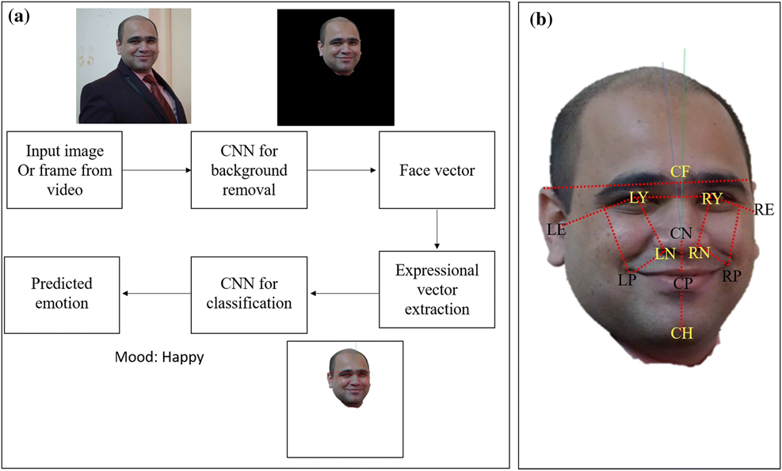

Fig 1.describing the flowchart of the process Fig 2.describing how the method is applied on a human face

**CODE SCREENS:**

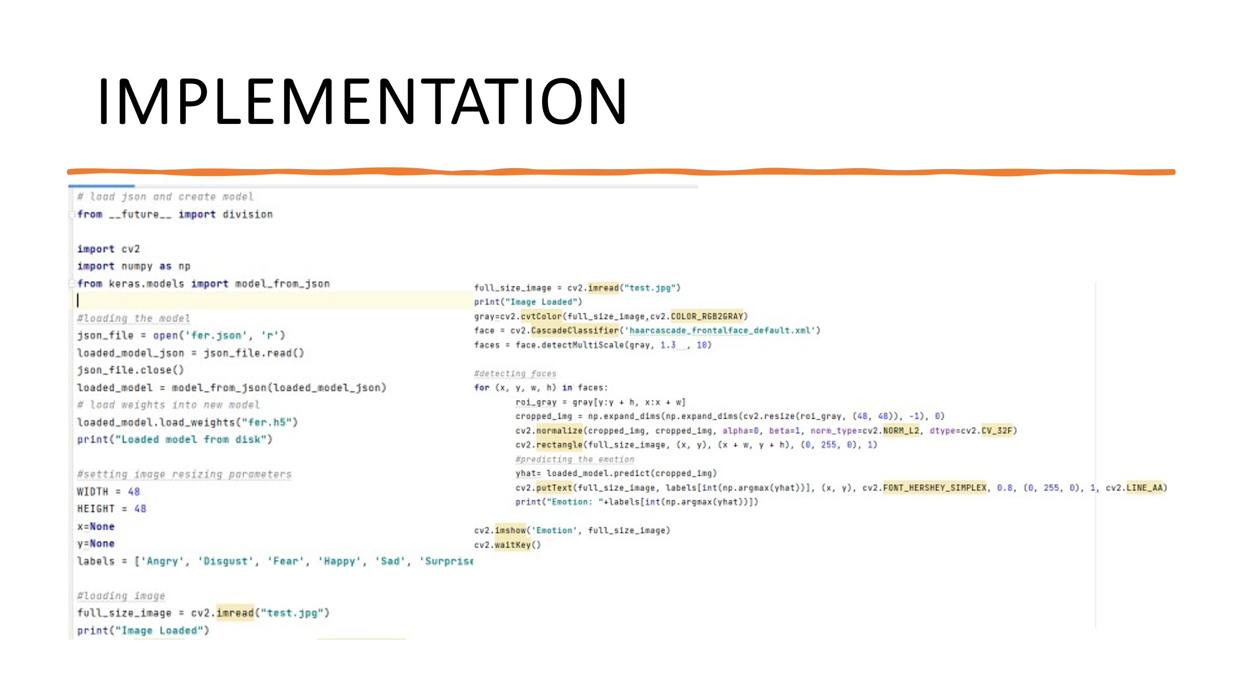

**RESULT:**

* We tried to develop the code which will take image file as an input and search for the facial landmarks and based on the datasets provided, the system will give the output of the expression of the user in image.
* In the process of developing, we encountered numerous errors and failures, some of the major errors were, the system failed to provide efficient results to the user, we rectified the errors by using different datasets which are reliable.

We mainly use the concepts of deep learning, library TensorFlow for this procedure of the identifying emotions.

**CONCLUSION:**

* FERC is a novel way of facial emotion detection that uses the advantages of CNN and supervised learning (feasible due to big data). The main advantage of the FERC algorithm is that it works with different orientations (less than 30°) due to the unique 24-digit long EV feature matrix. The background removal added a great advantage in accurately determining the emotions. FERC could be the starting step, for many of the emotion-based applications such as lie detector and also mood-based learning for students, etc.

**FUTURE ENHANCEMENTS :**

As of now the project’s only aim is to detect the face in the frame and to capture the facial landmarks and to match with the dataset and provide the output based on them. In future we would like to develop the system in to an autonomous unit by using the concepts of i.ot and artificial intelligence. We would like to develop a machine learning algorithm which would react with the user based on their emotions, for example if a man is driving the car at 90kmph and if he is drowsy the machine detects the emotion and sends alarming messages to driver through various methods.

**SOCIAL CONTRIBUTIONS**:

* According to the surveys, we conducted ,

1. According to the survey  
   1.around 82%of times, accidents occur due to drivers’ fatigue and lack of concentration on road and around 94% of time, the driver dies due to late arrival or not arrival of help.  
   2. around 65% of time, the airport authority fail to identify smugglers
2. There are times where the police could have stopped an incident from occurring, if only they didn’t think that he was not a criminal.
3. With our revolutionary project, the program reads the face expression of the personality and provides the exact emotion of the person.
4. For example: if a person is thinking to commit a crime, then generally the person will be tensed , distressed etc . If the program reads all the emotions, then based on all the emotions and match with the datasets it would create and alert to the user.

With the development of our revolutionary technology, we can easily tackle such kind of miscellaneous activities, also our technology Is useful in case of physical handicapped people, most of time people with disabilities their words remain unheard to people, for such people with few modifications to our project we can bring them voice. Also our application, can be used in security, since our application scans the human face to read out their expressions, it can easily track down people with wrong intentions. Also the application can be used in medical usage also, if a person is a having a heart attack then his expression will change to distressed or stressed, then the doctor can easily identify that something Is wrong with the patient. These are social applications from our project.

**DECLARATION**

The Social Internship Report entitled “FACIAL EMOTION DETECTION ”is a record of bonafide work of

K MANIDEEP REDDY (2010030309),

I KAUSTUBH SASTRY (2010030064),

K.V. MANOHAR KARTHIK (2010030197),

M.ABHIRAM (2010030457)

submitted in partial fulfillment for the award of B.Tech in the Department of Computer Science and Engineering to the K L University, Hyderabad. The results embodied in this report have not been copied from any other Departments/ University/ Institute.

<Signature of the Students >

K MANIDEEP REDDY(2010030309)-

I KAUSTUBH SASTRY(2010030064)-

K.V.MANOHAR KARTHIK(2010030197)-

M.ABHIRAM(2010030457)-

**CERTIFICATE**

This is to certify that the Social Internship Report entitled “FACIAL EMOTION DETECTION” is being submitted by K MANIDEEP REDDY (2010030309),I KAUSTUBH SASTRY(2010030064),K.V.MANOHAR.KARTHIK(2010030197),M.ABHIRAM (2010030457submitted in partial fulfillment for the award of B.Tech in Computer Science and technology(C.S.E) to the K L University, Hyderabad is a record of bonafide work carried out under our guidance and supervision.

The results embodied in this report have not been copied from any other departments/ University/Institute.

## Signature of the Supervisor

Dr.K.Sreenivasa Rao(Professor)

## Signature of the HOD Signature of the External Examiner

Dr. Chiranjeevi Manike

**ACKNOWLEDGEMENT**

First and foremost, we thank the lord almighty for all his grace & mercy showered upon us, for completing this Social Internship successfully.

We take grateful opportunity to thank our beloved Founder and Chairman who has given constant encouragement during our course and motivated us to do this Social Internship. We are grateful to our Principal **Dr. L. Koteswara Rao** who has been constantly bearing the torch for all the curricular activities undertaken by us.

We pay our grateful acknowledgement & sincere thanks to our Head of the Department **Dr. Chiranjeevi Manike** for her exemplary guidance, monitoring and constant encouragement throughout the course of the Social Internship. We thank **Dr.K.Sreenivasa Rao** of our department who has supported throughout this Social Internship holding a position of supervisor.

We whole heartedly thank all the teaching and non-teaching staff of our department without whom we won’t have made this Social Internship a reality. We would like to extend our sincere thanks especially to our parent, our family members and friends who have supported us to make this Social Internship a grand success.